

Laser Systems Ltd.

**PULSED DOPPLER WIND LIDAR**

**WINDEX-2000**

Operation manual

St. Petersburg

2017

**TABLE OF CONTENTS**

1 Description and OPERATION 4

1.1 General description 4

1.2 Technical specifications 5

1.3 Delivery set 6

1.4 Operation principles and structure of the device 7

2 MOUNTING AND DISMOUNTING 17

2.1. General directions 17

2.2 Requirements to a site 17

2.3 Requirements to electrical connection lines 17

2.4 Mounting 19

2.5. Dismounting 23

3 HOW TO Use 24

3.1 Operational restrictions 24

3.2 Switching on: 24

3.3 Scanning 24

3.4 Switching off: 25

3.5 Actions in emergency situations 26

4 Technical maintenance 27

4.1 General instructions 27

4.2 Safety measures 27

4.3 Technical maintenance procedures 27

4.4 Works on technical maintenance 27

4.5 Order of works on Technical Maintenance 29

4.6 Operational check 40

5 operating repair 41

5.1 General instructions 41

5.2 Safety measures 41

5.3 Malfunctions and ways of their elimination 41

6 Storage, preservation and UTILIZATION 45

7 packaging and Transportation 47

8 StATEMENT OF WARRANTY 48

9 FACTORY ACCEPTANCE 49

10 THERMAL STABILIZATION SYSTEM INFORMATION 50

This operation manual (henceforth – OM) provides description and operation principles of the Pulsed Doppler Wind Lidar WINDEX-2000 (henceforth – WINDEX-2000, the device or the product), and also sets main requirements to operation, technical maintenance, repair, storage, transportation, and utilization.

Only specially trained personnel studied this OM and other technical documentation for the device, gone through safety instructions, are authorized to operation, service, and repair of WINDEX-2000.

WINDEX-2000 does not jeopardize a person’s health and it is designed for operation in the places where free access is limited.

It is FORBIDDEN to look at optics of the device via magnifiers (glasses, binoculars, telescopes, etc.) while it’s under operation. Make sure that nobody looks at it from the beam direction using magnifying optics.

The product has the following warning signs:

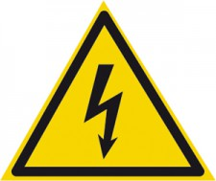

# Description and OPERATION

## 1.1 General description

WINDEX-2000 is intended for operational remote measurement of vector direction and speed rate of air flows at different distances, for visualization and display of the measurement results.

WINDEX-2000 allows making the following actions remotely:

– define vertical speed profile and wind direction;

– define horizontal wind shift and vertical gusts;

– perform 3D mapping of wind fields.

The appearance of WINDEX-2000 is provided in figure 1.

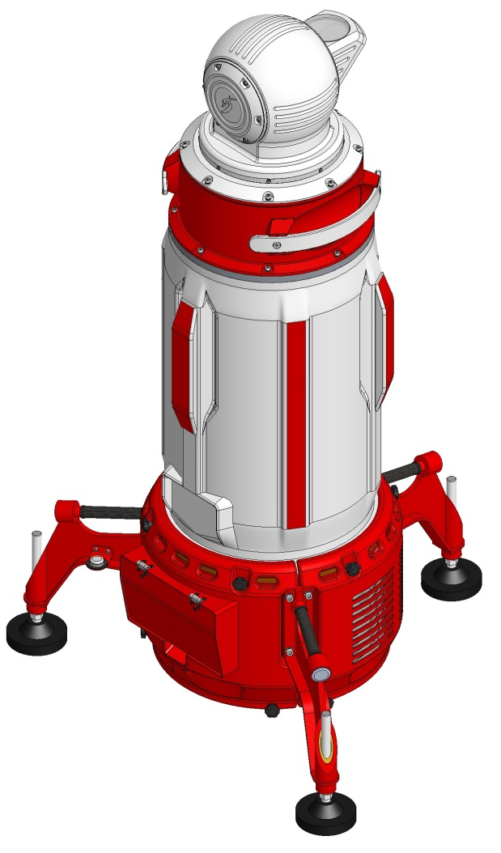 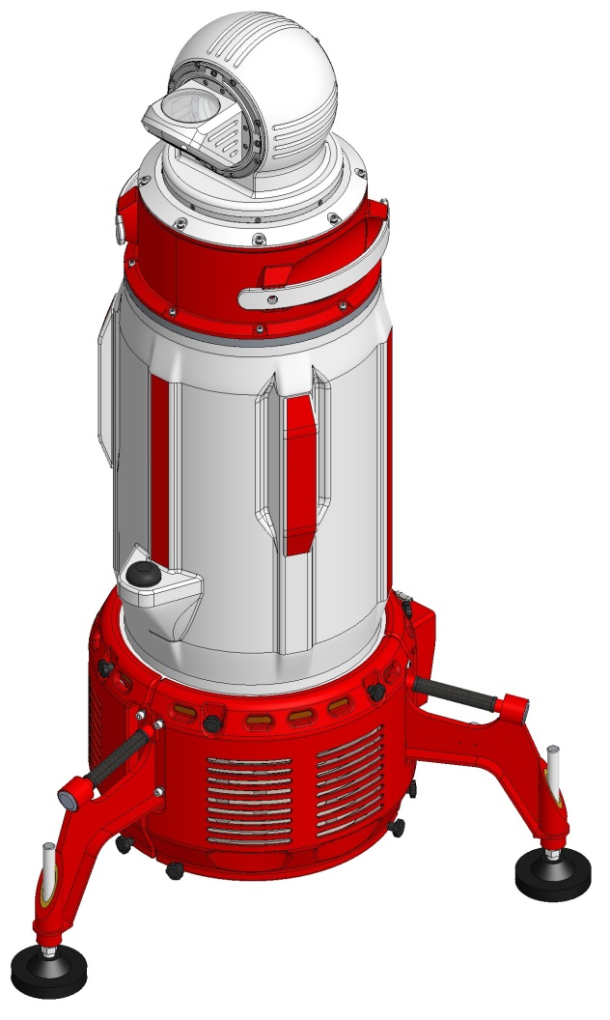

Figure 1 – WINDEX-2000 appearance

## 1.2 Technical specifications

The main technical specifications of the product are presented in the Table 1.

Table  – Technical specifications

| **Parameter** | **Value** |
| --- | --- |
| Maximum range of wind parameters measurement, not less than* | 2500 m |
| Minimum range of measurement, not more than | 100 m |
| Vertical resolution, not more than | 60 m |
| Scanning range:  -azimuth  -elevation | 0 … 360°  - 10 … 190° |
| Accumulation time, not more than | 1 – 10 s (selectable) |
| Wind direction measurement accuracy, not more than | ±5° |
| Wind direction measurement range | 0 … 360° |
| Range of measurable wind speed | 0 … 60 m/s |
| Wind speed measurement accuracy, not more than | ± 1 m/s |
| Laser source wavelength | 1560 ± 10 nm |
| Laser source operation mode | pulsed |
| Data transfer interface | Ethernet |
| Power supply | 220 ± 10% VAC  60±1 Hz |
| Run time with a built-in DC source, not less than | 15 min. |
| Dimensions, L*W*H , not more than** | 1000 x 883 x 1647 mm |
| Weight, not more than *** | 140 kg |
| Operating temperature range | - 40 … 50°C |

* Maximum measurement range depends on various parameters of the atmosphere such as visibility, type of aerosols, air turbulence and etc., also on the accumulation time.

** Height of the Equipment with retracted adjustable support mounts

*** Equipment weight without packing, cables and spare parts kit.

## 1.3 Delivery set

WINDEX-2000 delivery set and delivery options are finally defined by the supply contract/purchase order. The list of general items is presented in the Table 2.

Table 2 – Delivery set

|  |  |
| --- | --- |
| Description | Quantity |
| Pulsed doppler wind lidar WINDEX-2000 | 1 pc |
| Client software | 1 CD |
| Set of connecting cables* | 1 set |
| Spares and tools kit | 1 set |
| Service kit | 1 set |
| Distribution box* | 1 pc |
| Operation Manual | 1 pc |
| User Manual | 1 pc |
| Package set | 1 set |

* Delivery option

Spares and tools kit is needed for operation, maintenance and repair of the device and its modules. Spares and tools kit content is presented in the Table 3.

Table 3 – Spares and tools kit

| Description | Quantity |
| --- | --- |
| Fastening elements | 1 set |
| Sealing rings | 1 set |
| Cotton gloves | 2 pairs |
| Connectors, terminals, fuses | 1 set |
| Lint free wipes | 1 box |
| Liquid for cleaning optics | 1 bottle |
| Hex keys | 1 set |
| Screwdrivers | 1 set |
| Desiccant | 10 packages |
| Air filter element | 4 pcs |
| Rag | 1 set |
| Cable tie | 1 package |
| Lubricant (lithium grease) | 1 tube |
| Lamp Т4 24V 50 W | 2 pcs |
| Fans | 1 set |
| Desiccant | 1 kg |

## 1.4 Operation principles and structure of the device

1.4.1 Operation principle

WINDEX-2000 operation is based on measurement of Doppler shift of scattered and reflected radiation frequency for evaluation of wind speed, direction, and shift.

WINDEX-2000 operation principle is described in this chapter. Transmitting-receiving telescope forms a space in the atmosphere where radial projection of wind speed is measured. Scanning module directs optical axis in azimuth and elevation angles and provides necessary scanning and visualization modes. Scanning modes are set be the user.

Figure 2 represents a diagram of the device receiving-transmitting system.

Pulsed fiber laser (1) radiation is divided into main and reference parts.

Main part of radiation goes to laser amplifier (2) to be amplified up to the necessary level. Through the circulator (3) amplified radiation passes to transmitting-receiving telescope (4) and then through the scanner mirrors directs to the atmosphere. After mixing of reference light with the radiation received from the atmosphere on fiber optical coupler (5) radiation goes to balanced heterodyne detector (7).

Reference radiation is used as heterodyne reference radiation which goes to an attenuator (6) to be attenuated to the necessary level. Then it goes to fiber optical coupler (5) where it is coupled with the scattered radiation received from the atmosphere. After mixing of reference light with the radiation received from the atmosphere on fiber optical coupler (5) radiation goes to balanced heterodyne detector (7).

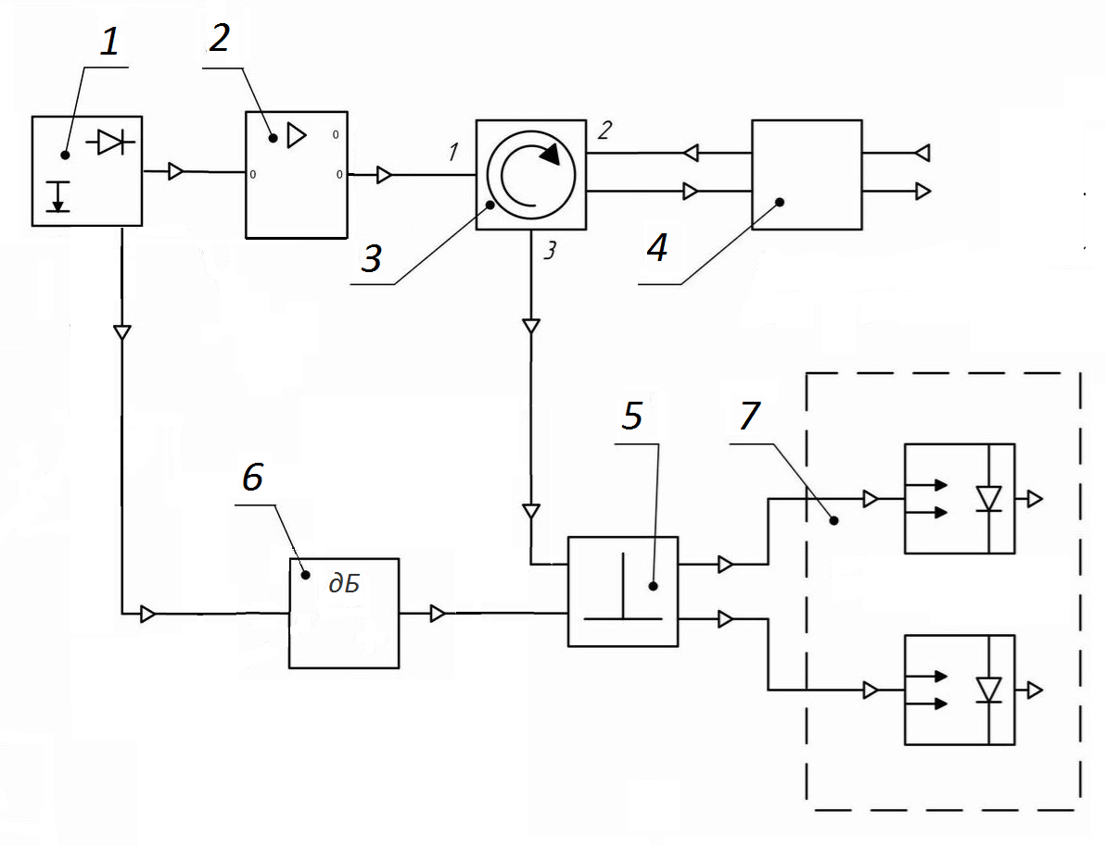

Figure 2 – Transmitting-receiving system diagram

1.4.2 WINDEX-2000 structure

WINDEX-2000 consists of three main modules (Figure 3):

– scanning module;

– optical-electronic module;

– cooling and power module.

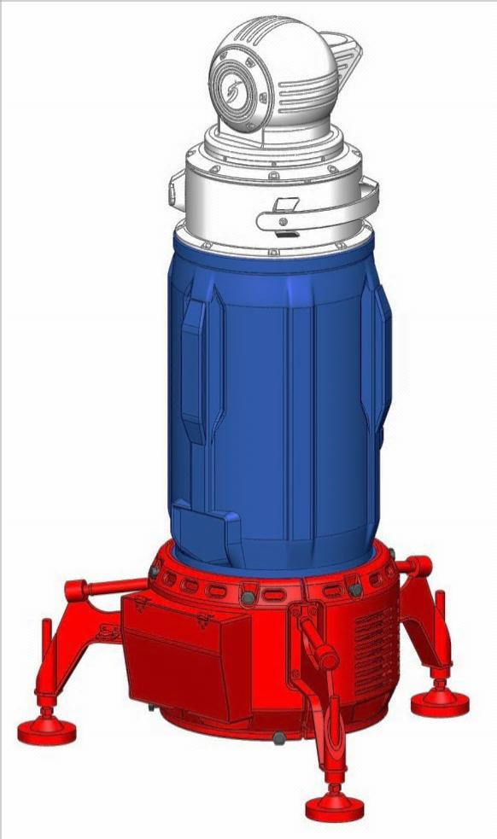

Cooling and power supply module

Scanning

module

Optical-electronic module

Figure 3 – Main modules

1.4.3 Cooling and power module

1.4.3.1 Cooling and power module structure

The cooling and power module (Figure 3) is located in the case and additionally protected outside by a false case. There are two rechargeable batteries, a cooling module, a temperature stabilization module and a secondary power supply module inside the case.

A cylindrical bubble level for control of the device right installation on a surface is fixed on one of the support mounts.

Each of the support mounts has a carrying handle.

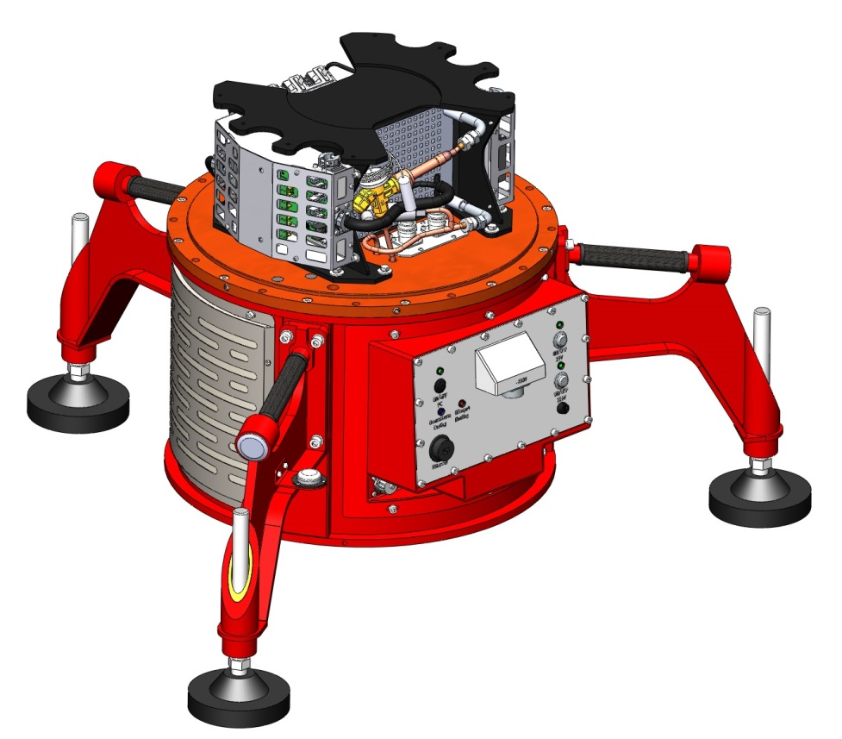

Adjustable support mount

Control and power

board

Lid with a filter

Carrying handle

Cooling

module

Figure 4 – Cooling and power module in a case

1.4.3.2. Thermal stabilization system

A thermal stabilization system diagram is presents in figure 5.

A thermal stabilization system consists of thermal stabilization module, cooling module and heating elements.

Thermal stabilization module provides setting and keeping of normal operation temperature, controls humidity, presence of electrical power and batteries condition.

Heating elements provide necessary working temperature inside the case at negative outside temperatures to start operation and keep it during the operation.

The cooling module is made as a refrigerating system on the base of a compressor for cooling of internal area. Main components of the cooling circuit are the following: a compressor, a condenser, an evaporator and a ventilator. They are connected by pipelines in a closed-circuit system where refrigerant circulates.

While refrigerant circulates it transits from liquid to gas and vice versa. With help of such transitions heat is transferred from one part of the thermal stabilization system to another.

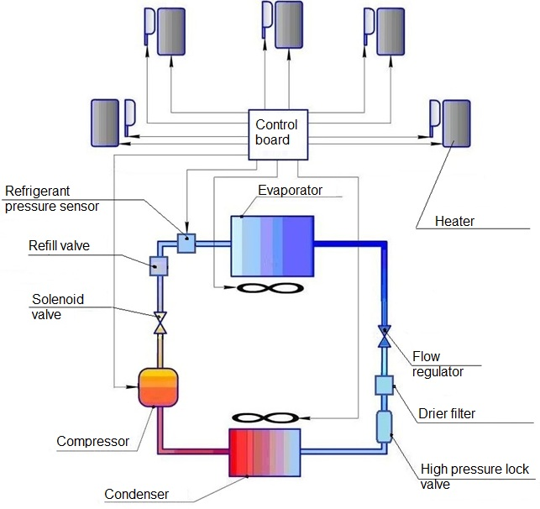 Figure 5 – Thermal stabilization system structural diagram

Through the evaporator compressor resorbs refrigerant in cold gas state under low pressure, compresses and pumps it in hot gas state into the condenser. A compressor is a spot in a refrigerant circuit where low and high pressure is divided.

Inputs and outputs of a compressor are equipped with dampeners to damp vibrations which appear during the operation of a system. Refrigerant in a hot gas state passes into the condenser.

Cold outside air passes through the condenser and takes away heat, so the refrigerant cools. The cooled refrigerant condenses and transits into a liquid state, after which it goes to the drier filter.

A valve for locking the high pressure area when the system is switched off is installed after drier filter. Then the refrigerant enters into the evaporator, boils and finally transits into a gas state. The evaporation process requires big amount of energy, as a result of this transition the case cools. The refrigerant passes from the evaporator into the compressor in a gas state.

Then the whole cycle repeats.

A pressure sensor controls refrigerant amount.

Refilling valve is installed for refilling the system with refrigerant.

1.4.3.3. Control and power board

The control and power board is located outside the case of the cooling and power module (Figure 6). The board has on/off buttons and indicators, connectors for power and network connection and service operations

27V indicator

Embedded PC indicator

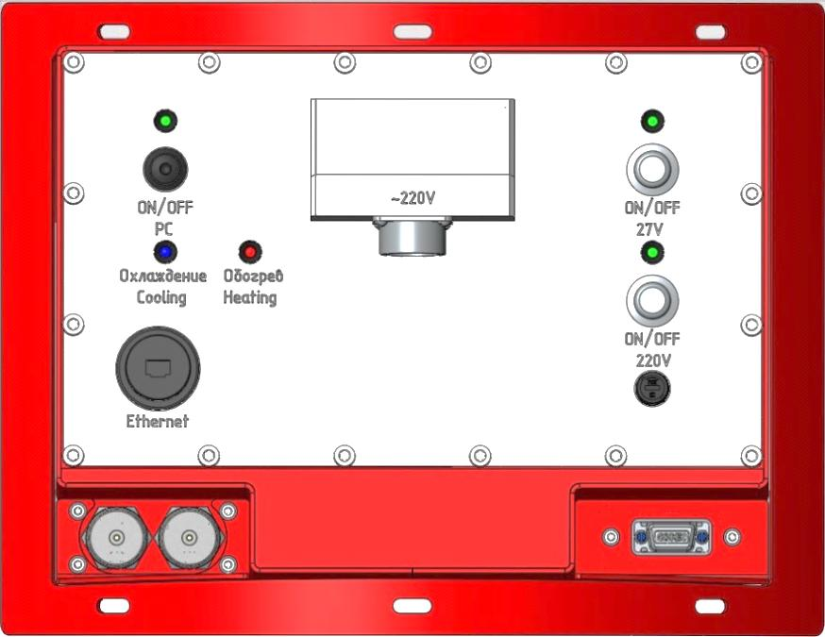

Power connector

Fuse

220V power button

27V power button

220V indicator

Ethernet connector

Heating and cooling indicators

Embedded PC on/off switching button

Figure 6 – General view of the control and power board

Cooling and heating indication description is presented in table 4.

Table 4 – Cooling and heating indication description

|  |  |  |
| --- | --- | --- |
| Indicator | | WINDEX-2000 state |
| Cooling | Heating |
| — | — | Normally operating or turned off |
| — | lit red | heating |
| lit blue | — | cooling |
| lit blue | lit red | Thermal stabilization system is defected  (service is needed) |

Heating is on at a temperature below 10°C inside the case; cooling is on at a temperature above 25°C.

1.4.4. Optical-electronic module

The optical-electronic module (Figure 7) is constructed as a frame where an optical node, a signal processing module, a compass, a laser source, ADC module, GPS module, fan heater, a remote restart device, an amplifier, a photodetector and a compressor controller are mounted.

The casing is made of glass fiber laminate with aluminum hanging flanges; it is coated inside with a heat insulation layer; there are two auxiliary handles on each side of the casing.

1.4.5 Scanning module structure

The scanning module (Figure 8) includes a rotation unit, an inclination unit and an inclined mirror unit. Module units are covered with glass fiber casing installed on aluminum body. There are two auxiliary handles on each side of the module.

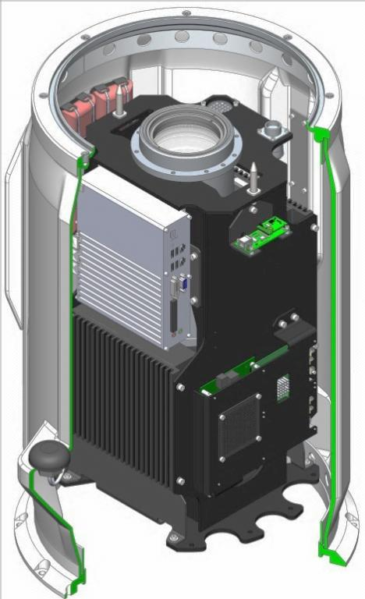 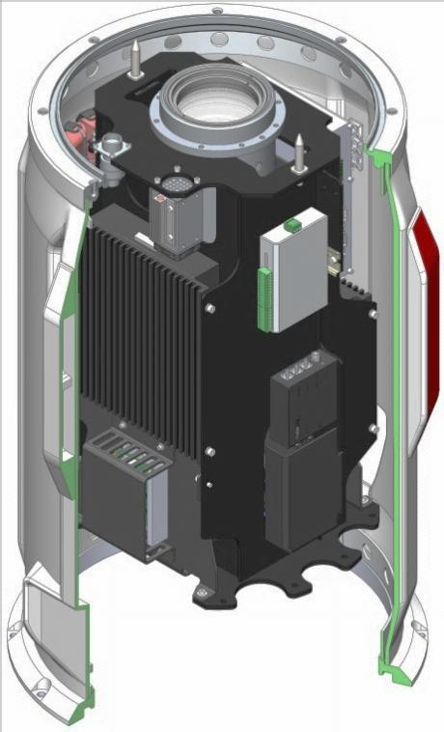

Photodetector

Compressor controller

Amplifier

Remote restart device

Heat ventilator

GPS module

ADC module

Compass

Optical

node

Laser source

Processing module

Figure 7 – Optical-electronic module configuration

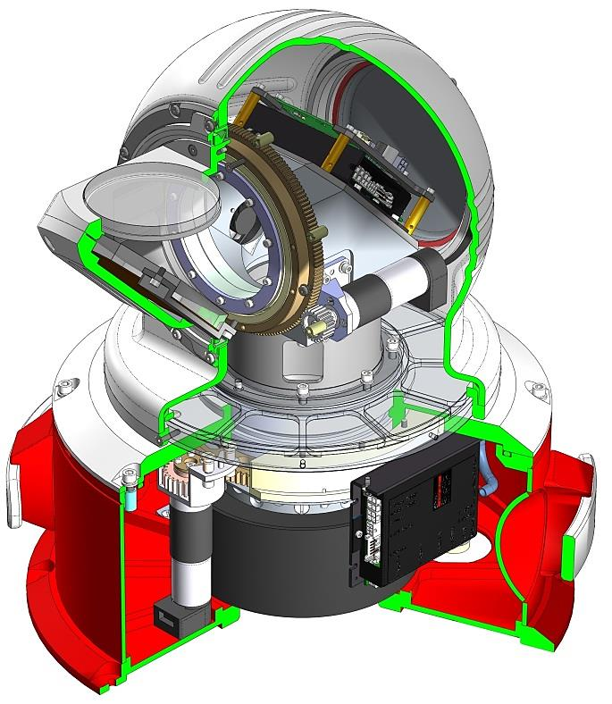

Body

Inclination unit

Casing

Inclined mirror unit

Auxiliary

handles

Rotation unit

Figure 8 – Scanning module in casing

1.4.6 Service kit

Service kit is needed for connecting to embedded PC for performing service works, setting of operation system and software.

Service kit consists of:

|  |  |
| --- | --- |
|  | LCD monitor with cables |
|  | USB keyboard |
|  | USB Mouse |
|  | Ethernet Cat.5e 2м patch cord |
|  | Power cable for connecting to 220V |

LCD monitor is connected to VGA connector for display image from the embedded PC.

Keyboard and mouse are connected to USB service connectors (Figure 9).

Power cable and Ethernet patch cord are used when it is necessary to launch WINDEX-2000 outside of equipped site.

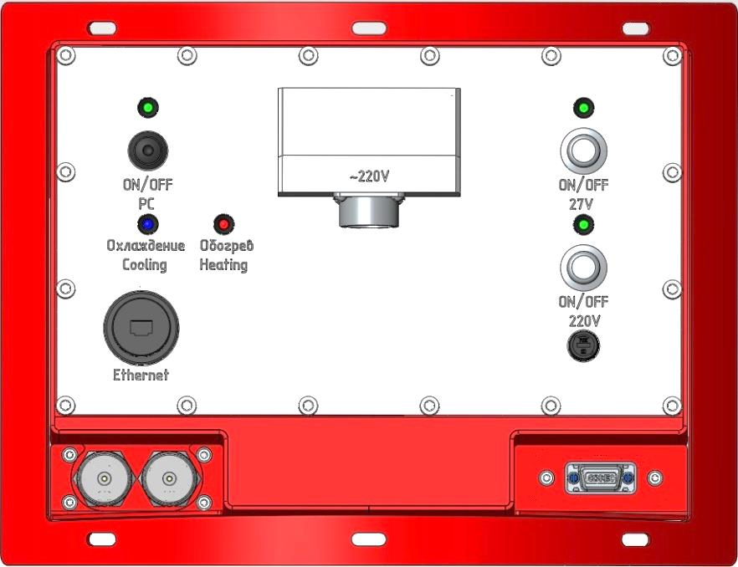

Power connector

VGA service connector

USB service connectors

Ethernet connector

Figure 9 – Service connectors on a power and control board

# MOUNTING AND DISMOUNTING

## 2.1. General instructions

Upon receipt of the product, it is necessary to be assured of package integrity. In case of damage detection it is necessary to record damages on the place of cargo receipt by any means available and to make a claim to a shipping company.

Mounting and dismounting should be made by competent personnel studied technical documentation and this manual, having admission to work with electrical installations up to 1000V, and with observance of relevant safety rules.

Mounting and dismounting should not be carried out under atmospheric precipitations and gusts of wind up to 15 m/s.

## 2.2 Requirements to a site

The product should be installed on the concrete level ground having 1500 x 1500 mm in size as least; maximum inclination of a site should not exceed 5°.

Free access of service personnel has to be provided to the equipment on the site.

When selecting location it is necessary to consider that existence of disturbances in a beam path that create additional air flows, i.e. hills, high-rise buildings, large moving objects, power transmission line towers, introduces additional errors to measurement results.

It is possible to install the product on an unprepared surface, i.e. level, dense, and solid ground; relief slope admissible angle is not more than 5°. In case of installing on loose grounds it is recommended to use additional platforms for supports.

Measures preventing precipitation accumulation should be provided on the site.

## 2.3 Requirements to electrical connection lines

The following cables should be supplied to the prepared site:

- single-phase alternating current power line of 220 V ± 10% with a frequency of 50/60 Hz, with power not less than 1 kW;

- screened twisted pair (ANSI/TIA/EIA 568 standard cable) with wire section not less than 26AWG (0,12 mm2). The distance between the Equipment and LTE-router shall be no longer than 100 m. The capacity of the channel between the Equipment and PC, united in one network through LTE-router shall be at least 50 Mbit / s;

- grounding device consisting of a vertical grounding bar and a grounding conductor;

- external lightning protection (lightning arrester, lightning rod, grounding) and lightning protection of current distribution networks to eliminate switching noise in accordance with existing regulations.

Cables shall be run in a non-metallic pipe of nonflammable materials and shall be able to operate at temperatures from -40 ° C to 50 ° C and relative humidity up to 100%. Cables should be fire-resistant, flame retardant, with low smoke and gas emission, low toxicity of combustion products and protected from direct sunlight and precipitation. When the cables lines are run parallel distance between the power cable and communication cable should be at least 100 mm.

Recommended network cable SFTP4-ST (01-0343).

Resistance of a grounding device, to which neutral sources of single-phase current are attached should be no more than 8 ohms at any time of the year;

Vertical grounding bar made of galvanized steel as a grounding device shall be a minimum diameter of 12 mm and a length of at least 2 m, and laid at a depth of not less than 0.5 m. Vertical grounding bar shall be installed at least 1 m distance from the edge of the site.

Cross-section of separately laid copper protective (grounding) conductor must be at least 4 mm2.

Cross-section of separately laid aluminum protective (grounding) conductor must be at least 16 mm2.

As a natural grounding the following items can be used:

1) metal and concrete structures of buildings which are in contact with the ground, including reinforced concrete foundations of buildings which have a protective waterproofing coating in non-corrosive, slightly aggressive and moderately aggressive environments;

2) metal water pipes laid in the ground;

3) the casings of boreholes;

4) metal sheet pilings of hydraulic structures, penstocks;

5) the main non-electrified rail tracks and railway sidings with an intentional device jumper between the rails;

6) other metal structures located in the ground.

## 2.4 Mounting

Unpack and set the distribution box (Figure 10). Fix it on the site by anchor bolts of a size up to M12 (bolts are not included in the delivery set and could be delivered optionally). The height of the distribution box is 808 mm; the basis size is 249 x 300 mm.

Unpack the product:

–set a box on the basis in accordance with the marking on sides of a box, open a top cover;

– mount the third support of the product which is removed for the purpose of shipment;

– release the product from transit brackets, remove from a box in vertical position using carrying handles on supports (by three persons at least), holding for auxiliary handles on a casing;

–install the parts of the false case which are removed for the purpose of shipment on the cooling and power module with fastening elements from a delivery set.

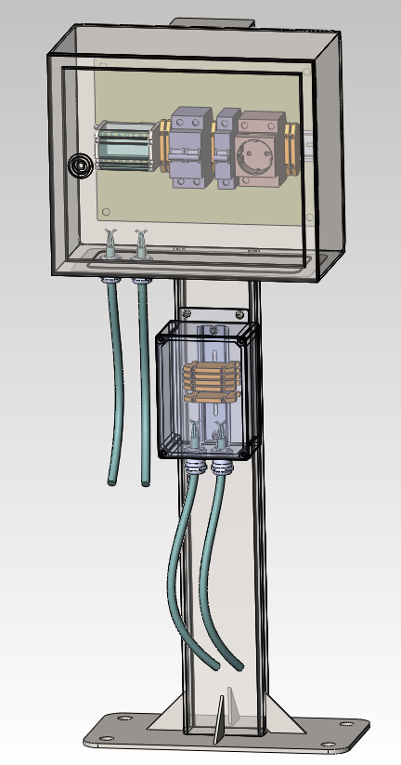

To WINDEX-2000

Network terminals

Circuit breaker for 220V socket

Additional 220 V terminals

Grounding bus

To WINDEX-2000

Two-phase circuit breaker

220 V socket

Mounting holes

Grounding bus

Figure 10 – Distribution box

Locate Windex-2000 on the site with respect to the global coordinates using a compass and corresponding label on a body.

Using a bubble level and retractable support mounts (Figure 11) fix WINDEX-2000 in a vertical position. Fix the product on the site by anchor bolts of a size up to M12 (bolts are not included in the delivery set and delivered optionally).

ATTENTION! INSTALLATION OF THE PRODUCT SHOULD EXCLUDE ITS SELF-MOVEMENT OR SPONTANEOUS DEVIATION FROM THE VERTICAL AXIS.

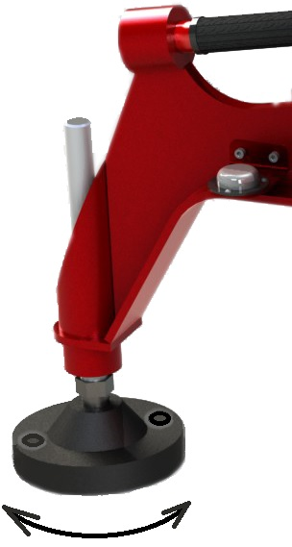

Bubble level

Places for fixing holes

Figure 11 – Retractable support mount

If installing on soil fix the product by dowels up to 12 mm in diameter (dowels are not included to the delivery set and can be delivered optionally).

Plug in WINDEX-2000 to a power and network lines.

ATTENTION! ROUTING, DRESSING AND ASSEMBLY OF CABLES AND WIRES SHOULD BE DONE ONLY AT POWER-OFF.

Connect the product via bolted-type connection at the case of power and cooling module to the grounding bar by corresponding cables from the delivery set (Figure 12).

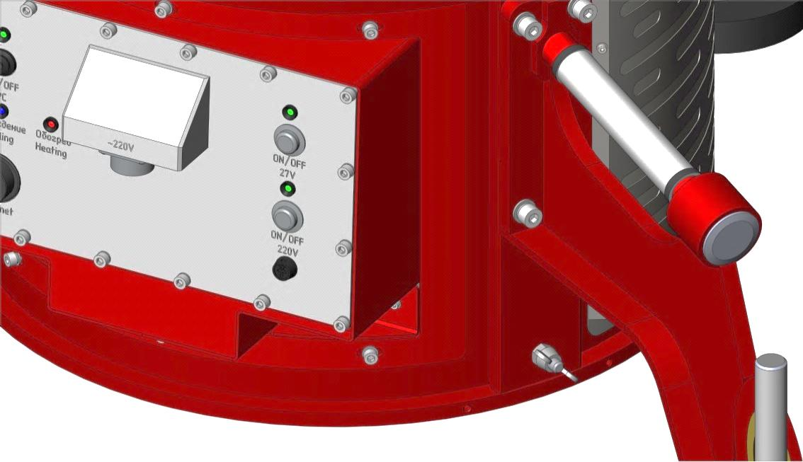

Bolted connection

Figure 12 – Bolted-type connection

After transportation or long-term storage it is necessary to check and recover all detachable joints on terminals of rechargeable batteries if necessary (Figure 13).

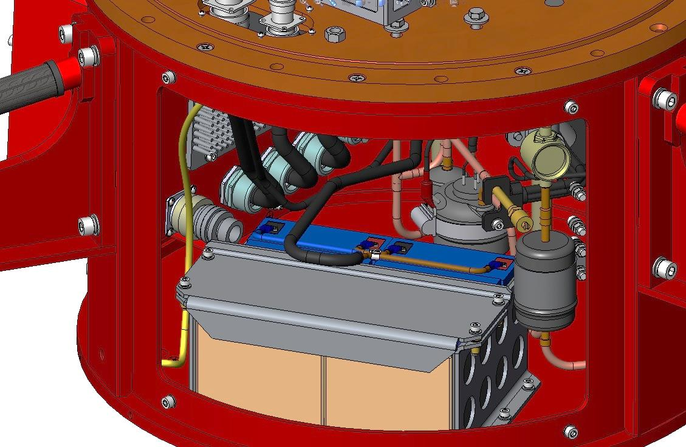

Control and power board from the inner side

Terminals

Figure 13 – Rechargeable batteries

In the course of WINDEX-2000 continuous operation within several days rechargeable batteries will be charged to the maximum value. Data on charge quantity are displayed in software on the operator’s remote computer.

After the end of mounting wipe the product with wet rag. Wipe a protection glass on the scanning module with a lint-free wipe moistened with liquid for wiping optics.

## 2.5. Dismounting

ATTENTION! DISMOUTING SHALL BE MADE ONLY AT POWER-OFF!

Disconnect WINDEX-2000 from a power supply line, communication lines, grounding bars.

Switch-off all connection cables, wipe with a wet rag, then with a dry rag and pack into a shipping box.

Remove parts of the false case, wipe with a wet rag, pack into the shipping box and secure with transit brackets.

Remove anchor bolts from WINDEX-2000 support mounts, retract support mounts up until tight. Wipe the product with a wet rag then with a dry rag, prepare the shipping box according to the marking on its sides.

Put the product in the shipping box using handles on support mounts (by at least three persons). Secure the product in the box by transit brackets. Remove the third support mount, secure in the box with transit brackets.

If necessary insulate disconnected power supply lines.

# HOW TO Use

Service staff should:

* study the manuals;
* perform technical maintenance of the product;
* perform the operation test of the product.

## 3.1 Operational restrictions

The product can be operated under the climatic conditions specified in the Table 1.

OPERATION IS NOT ALLOWED:

* under hail;
* without grounding and lightning protection;
* in case of water or other liquid ingress inside the body.

Windex-2000 switching on is performed after product’s mounting, connection to power supply lines, communication lines, and grounding system.

## 3.2 Switching on:

Switch on the “220V” button, and then to switch on the “27V” button on the control and power board. Wait till normal operation temperature setting and for establishing connection with operator’s remote computer (from several minutes till half an hour depending on ambient air temperature);

Programmatically set necessary parameters and make measurements.

## 3.3 Scanning

The product monitoring and performance control, as well as visualization of measurement results, are carried out in real-time mode using operator’s remote computer with installed client software from a delivery set.

3.3.1 The client software is designed for solving the following tasks:

– start and stop of scanning;

– automatic data receiving and processing from WINDEX-2000;

- controlling scanning settings (mode and parameters selecting);

- creating and storing scanning templates;

- visualization of received data and scanning results in text and graphic formats in real-time mode;

– storing and display of scanning results;

- receiving diagnostic data about the product status.

Software allows setting the following main scanning modes or a combination of these modes:

- Range Height Indicator (RHI) – elevation angle is scanned in any range at a fixed azimuth angle;

– Plan Position Indicator (full circle or sector) (PPI) –scan angle is varied continuously in azimuth with a fixed elevation angle;

– Line-of-site (LOS) – azimuth and elevation angle are fixed during measurements;

– Vertical wind profiler (DBS) – measurements are made at several discrete azimuth angles (DBS, Doppler Beam Steering).

Note – all measurements data, device technical condition and user actions log for 30 days of non-stop operation are archived and stored in the remote computer memory.

Graphic interface and using of client software is described in details in User Manual.

## 3.4 Switching off:

* programmatically stop scanning;
* switch off the "27V" button, then the "220V" button on a control and power board.

## 3.5 Actions in emergency situations

At the emergency evacuation of service staff switch off the product and take measures to stop power supply to the working area. Further act on safety instructions issued by the operating organization.

In case of fire take measures for shutdown of power supply. Further act on fire safety instructions issued by the operating organization.

# Technical maintenance

## 4.1 General instructions

Technical Maintenance (TM) has a scheduled preventive character and consists of a complex of obligatory works on maintenance in order to keep the product in a good technically state and proper visual appearance.

When carrying out technical maintenance of the product and its components it is necessary to use tools and equipment from the spares and tools kit.

## 4.2 Safety measures

Qualified service personnel passed corresponding safety training and studied technical and operating instructions are authorized to perform technical maintenance.

Free access should be provided to components of WINDEX-2000.

When carrying out TM one should observe:

– safety requirements for working with laser radiation;

– safety requirements for working with electrical equipment.

## 4.3 Technical maintenance procedures

TM-1 is carried out monthly during operation and also in preparation of the product for use after transportation.

TM-2 is carried out once a half year, and also before placing in short-term storage (less than a year) regardless of time passed since last TM.

TM-3 is carried once a year, and also before placing in long-term storage (for a year and more) regardless of time passed since last TM.

## 4.4 Works on technical maintenance

Types of technical maintenance and content of works performed are provided in the table 5.

Table 5 – Types of technical maintenance and content of works performed

| Item of OM | Name of an object of TM and scope of works performed | Types of TM | | |
| --- | --- | --- | --- | --- |
| TM-1 | TM-2 | TM-3 |
| 4.5.1 | Appearance and mounting check | + | + | + |
| 4.5.2 | Check of connection cables | + | + | + |
| 4.5.3 | Inner inspection and cleaning of dust, replacement of desiccant and filters in optical-electronic module | + | + | + |
| 4.5.4 | Insulation resistance check | — | + | + |
| 4.5.5 | Ground resistance check | — | + | + |
| 4.5.6 | Check of operation of rechargeable batteries | — | + | + |
| 4.5.7 | Check of completeness, operational documentation and spares and tools kit | — | + | + |
| 4.5.8 | Replacement of lamps in optical-electronic module | — | — | + |
| 4.5.9 | Thermal stabilization system maintenance | — | — | + |
| 4.5.10 | Replacement of desiccant in power and cooling module | — | — | + |

"+" – mandatory operation

"—" – operation is not performed.

## 4.5 Order of works on Technical Maintenance

4.5.1 Appearance check and check of reliability of mounting of the product

|  |  |
| --- | --- |
| Tools:  a sweep-brush,  a hex keys set,  a screw-drivers set,  a brush.  Consumables:  lint free wipes,  optics cleaning liquid. | Clean the product:  - remove dust and dirt from external surfaces of the product’s parts with a sweep-brush and a rag. Wipe the colored surfaces – in the summer with a wet rag, and in the winter with a dry soft rag;  - remove dust from a control and power board with a dry brush and wipe it with a dry soft rag. |
| Wipe a protection glass of the scanning module with lint free wipe moistened with optics cleaning liquid.  Check protection glass for cracks. |
| Inspect the product. Check for mechanical damages, dents, corrosion and perishing. Repair damages and dents which are critical for performance. If impossible to repair replace damaged parts. |
| Check the cables for damages. |
| Check reliability of mounting of components, if there is a play tighten mounting screws and bolts in places of mounting. |

4.5.2 Check of connection cables

|  |  |
| --- | --- |
| Tools:  a sweep-brush,  a brush,  a hex keys set,  a screw-drivers set.  Consumables:  a rag,  optics cleaning liquid,  insulation PVC tape. | Wipe connection cables with a rag. |
| Check insulation for failures. Put on the points with insulation failure with a double layer of PVC tape with an overlap of not less than 50%, putting it with a tension and covering the undamaged insulating cover for 3–4cm at the edges. |
| Check the marking of cables, legibility of labels and reliability of fixing cables in connectors. |
| Check the condition of connectors and cleanliness of their contact surfaces. If necessary clean contact surfaces with a brush moistened with optics cleaning liquid. |

4.5.3 Inner inspection and cleaning of dust, replacement of desiccants and filters in optical-electronic module

|  |  |
| --- | --- |
| Tools:  a screw-drivers set,  a hex keys set, scissors.  Consumables:  a filter,  desiccant 8 pcs,  cable ties, lint free wipes, optics cleaning liquid, lubricant (lithium grease). | Switch off WINDEX-2000. Unscrew 4 screws of the false case which is situated to the right of the control and power board, remove the false case.    control and power board  false case  screws |
| Unscrew 4 screws, take off the lid with a filter. Disassemble a lid, replace a filter.    screws  lid with a filter  The filter is suitable for repeated application after washing and drying. |
| Unscrew 8 screws on the lower flange of a scanning module. Lift up the module, disconnect the harness from the connector, and remove the module from the body.    screws  body |
| Unscrew the screws which hold the telescope.    screws  Unscrew 8 screws by the perimeter, take off the body, disconnect GPS connector.  screws    catchers  GPS connector  casing |
|  | Dismount remaining details of the false case on the cooling and power module. Unscrew the screws on the lower flange, lift up the casing and disconnect grounding cable. Remove the casing  screws |
| Replace desiccant on the inner part of the casing with the new ones from the spares and tools kit, fasten them with the cable ties.    desiccant |
|  | Check the product modules for damages, dents etc.  Repair damages which are critical for performance. If impossible to repair damaged parts shall be replaced. |
| Check sealing rings and gaskets for cracks and tears, lubricate with lithium grease. If necessary replace the damaged parts. |
| After completion of the works assemble the device, wipe the telescope glass with the lint free wipe moistened with optics cleaning liquid. Reestablish all the connections during the assembling. Check WINDEX-2000 operability. |

4.5.4 Check of insulation resistance

|  |  |
| --- | --- |
| Tools: voltmeter, megaohmmeter | Switch off the product.  Switch off the power supply line at the site;  Switch off a two-phase automatic controller in the distribution box. Check the absence of AC voltage by voltmeter on the output of two-phase automatic controller, i.e. one probe to a terminal of the phase wire, the second probe to a terminal of the neutral wire.  Disconnect a power supply cable from the product.  Disconnect the wires N and L from the two-phase automatic controller and the wire PE from the grounding bar in the distribution box;    Two-phase automatic controller  Phase wire  Grounding wire  Neutral wire  Grounding bar  Using a megohmmeter make measurement of resistance to 2500 V voltage for 1 minute each:  - between a phase wire and a neutral wire (L – N),  - between a phase wire and a grounding wire (L – PE),  - between a neutral wire and a grounding wire (N – PE). |
| The received value of equivalent resistance of isolation of the connection cable should be not less than 0.5 megaohms. If less, then it is necessary to replace a cable. |

4.5.5 Check of grounding resistance

Perform a check of grounding resistance at relative humidity 45–80%. For checking use a current clamp C.A 6410 (or similar).

ATTENTION! To carry out works with current clamp only in insulating gloves.

|  |  |
| --- | --- |
| Tools:  current clamp,  insulating gloves. | Remove a protective cover from a grounding wire. Provide enough free space for capture of the conductor with a current clamp. |
| A clamp should be on the electrical path from the neutral of the system or from the grounding conductor to the probe. |
| Capture the grounding conductor by a clamp and measure resistance in the conductor. The measured value corresponds not only to resistance of the grounding system, but also includes resistance of a neutral contact with the probe and of all connections between a neutral and the probe. |
| The received value of grounding resistance should not exceed 0,1Ohms.  Above-limit value can be caused:  a) by poor grounding of the probe;  b) by a disconnected grounding conductor;  c) by high resistance of contacts or places of jointing of the conductor. |
| If failed to eliminate causes of exceeding value of grounding resistance, it is necessary to address to relevant specialists for check of the set grounding. |

4.5.6 Functional check of rechargeable batteries

A check is carried out on rechargeable batteries completely charged (voltage on the batteries can be measured by a multimeter) at a temperature of 25±5°C and humidity of not more than 80%. Full charge of batteries is made after few days of non-stop WINDEX-2000 operation.

Voltage of each battery shall be at least 12.5 V.

|  |  |
| --- | --- |
| Tools:  multimeter | Switch off the “220V” button on the control and power board when the product operating in a scanning mode. The “27V” button should remain switched on. Note the time. In 15 minutes switch on the 220V button. |
| If operation of the product is shut down before the expiration of 15 minutes it is necessary to charge the batteries with external charge device. After full charge the device shall operate at least 15 minutes at the power of batteries. If it does not it is necessary to replace batteries. |

4.5.7 Check of completeness, operational documentation and spares kit

|  |  |
| --- | --- |
| Tools:  a sweep-brush.  Consumables:  a rag. | Check completeness of the product. |
| Check for presence of operational documentation. |
| Check spares and tools kit:  - remove dust and dirt from spare parts and tools with a dry rag;  - check for presence and condition of spare parts, tools, and accessories;  - check correctness of packing. |

4.5.8 Replacement of lamps in optical electronic module

|  |  |
| --- | --- |
| Tools: hex keys set.    Consumables: lint free wipes, optics cleaning liquid. | Switch off the device, unscrew 4 hex screws and remove a pad.    screws  pad |
| Unscrew 8 hex screws and remove a clamping ring with a sealing and an inclined mirror node.    Clamping ring  screws  Inclined mirror node  sealing |
| Unscrew 8 screws by the perimeter and remove a casing.    casing  screws |
| Unscrew 2 screws and remove a lamp in housing. Replace a lamp and install a housing back.    screws |
| While assembling carefully wipe all the optical units with lint free wipe moistened in optics cleaning liquid. |
| After assembling perform operational check. |

4.5.9 Thermal stabilization system maintenance

If refrigerant pressure inside the circuit is lower than necessary level maintenance shall be performed despite of technical maintenance schedule.

Type and weight of refrigerant and oil and refilling date are specified in the chapter 10 of the current OM.

|  |  |
| --- | --- |
| Tools:  Equipment kit for conditioning systems refill (refrigerant balloon, vacuum pump, refill station), diagnostic kit. | Connect diagnostic monitor, keyboard and mouse to the service connectors of the device. |
| Remove false case details and lit with a filter as described in 4.5.3. |
| Stop the scanning in software.  Switch off the server.  Launch the thermal stabilization program TERMO located on desktop of embedded PC (figure 26). In appeared window select “Settings” and set COM10 port, press Start.  The program indicators shall lit green. On the MODES tab select MANUAL mode by pressing a corresponding button. On the RELE COMP tab press ON, set the value 0 in “refrigeration” and then press ON. |
| Tighten up the valve on refill station and connect the corresponding hose to the refill valve of the device.    Refill valve  The other hose shall be connected to a vacuum pump, turn on a pump and open a valve on refill station.  Vacuum pump will remove all the gas from the thermal stabilization system, distinctive sound of a pump will indicate that the process is completed. |
| Close the valve of refill station and switch off the pump. Connect a balloon with refrigerant instead of pump to the hose and put it on scales. Open the valve of refill station. In TERMO program set the value 2100 in “Refrigeration” tab and press ON, refrigerant will start to fill the system. The weight of filled gas shall be controlled according to the data from chapter 10.  Close the valve of refill station, disconnect the hose from the balloon and from WINDEX-2000. |
| In MODES tab select AUTO mode (Figure 14). Stop the program by pressing STOP and then “Close”. Close the program.  Switch on the server, set scanning parameters. Make sure that thermal stabilization system operates right by checking inner temperature during few cycles of operation.  Disconnect service monitor, keyboard and mouse. |

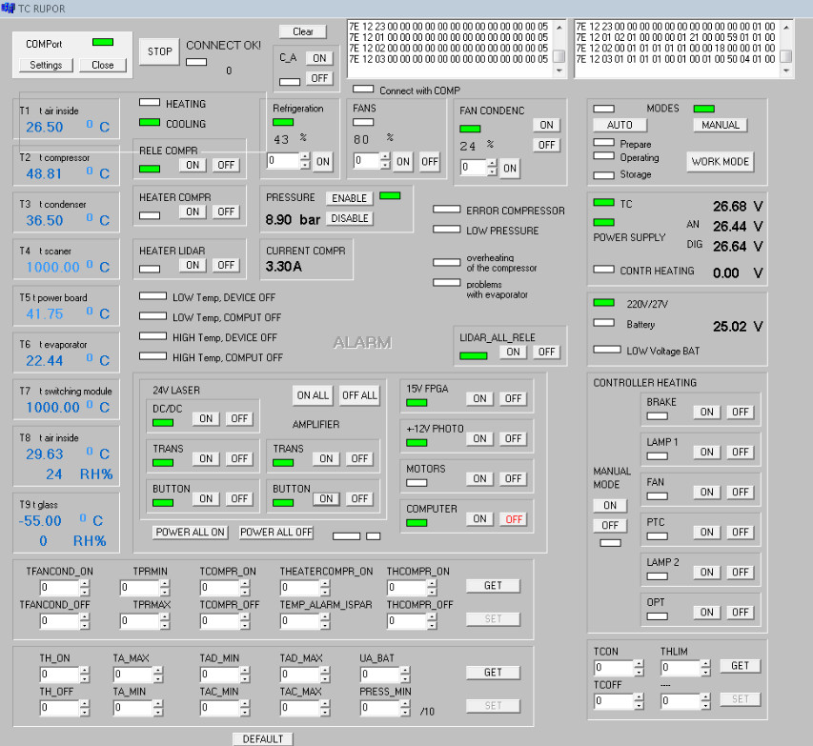

Figure 14 – TERMO program interface

4.5.10 Replacement of desiccant in cooling and power module.

|  |  |
| --- | --- |
| Tools:  screwdrivers set, hex keys set.  Consumables:  filter, 1 kg of desiccant | Remove false case details and lit with a filter as described in 4.5.3. |
| Remove a cap of a dehumidification unit and replace desiccant with the new one for spares and tools kit.  Dehumidification unit cap    Assemble the device |
| Desiccant after being dried may be used again. |

## 4.6 Operational check

Operation of the product is tested as follows:

–switch on the product (para. 3.2);

– after starting to operate in a normal mode perform single measurements at several heights (para. 3.3.4);

- check the measurement results in software on the remote computer;

–switch off the product (item 3.4).

# operating repair

## 5.1 General instructions

Carrying out any operating repair of the product should be approved by the manufacturer.

During the whole operating time of WINDEX-2000 automatic diagnostics of all systems is carried out and results are displayed in the software.   
Connectors for connection of service equipment are also provided in the product.

## 5.2 Safety measures

When carrying out operating repair it is necessary to observe safety measures:

– only qualified personnel studied technical and operational documentation, passed corresponding instructing is authorized to perform works on repair and service;

–connection and disconnection of the cables, installation and metal works shall be performed only at the disconnected power supply.

## 5.3 Malfunctions and ways of their elimination

The following issues indicate malfunction of Windex-2000 or its component:

– the program message on the operator’s remote computer;

– absence of indication on the control and power board;

– nonresponse of the equipment for operator actions.

Possible malfunctions, reasons and instructions on their elimination, are given in Table 6.

Table 6 – Possible malfunctions and ways of their elimination

|  |  |  |
| --- | --- | --- |
| Malfunction feature | Possible causes of malfunction | Elimination methods |
| Rechargeable batteries do not provide enough operating time | Loose connection between rechargeable batteries  Rechargeable batteries are out of order. Recharging circuit is out of order. | Check all connections between accumulator connections, tighten connectors  Replace rechargeable batteries  Contact manufacturer representatives. |
| Protection glass of the scanning module sweats | Saturation of desiccants  Penetration of water inside the module | Replace desiccants  Eliminate leakage causes |
| The product does not operate, the 220V and 27V buttons are switched on, no lightening of the 27V button | The fuse F1 is blown-out | Replace the fuse F1, 30A |
| The product does not operate, the 220V and 27V buttons are switched on, no lightening of the 220V button | No power supply on the line  The fuse FU1 is blown-out | Check a power supply line  Replace the fuse FU1, 10A |
| The product is switched off when 220V power is stopped | The fuse F2 is blown-out  Rechargeable batteries failed | Replace the fuse F2, 20A (figures 19, 21)  Check operability of rechargeable batteries |

5.3.1. To replace the fuses proceed as follows:

–switch off the product;

–disconnect power supply and communication lines on the control and power board;

–unscrew the screws and accurately take off the control and power board;

–pull out the appropriate fuse from the terminals on the back side of the power and control board. Replace the fuse with a new one from the spares and tools kit, keep the same value of a fuse;

- reassemble power and control board and reestablish all the connections.

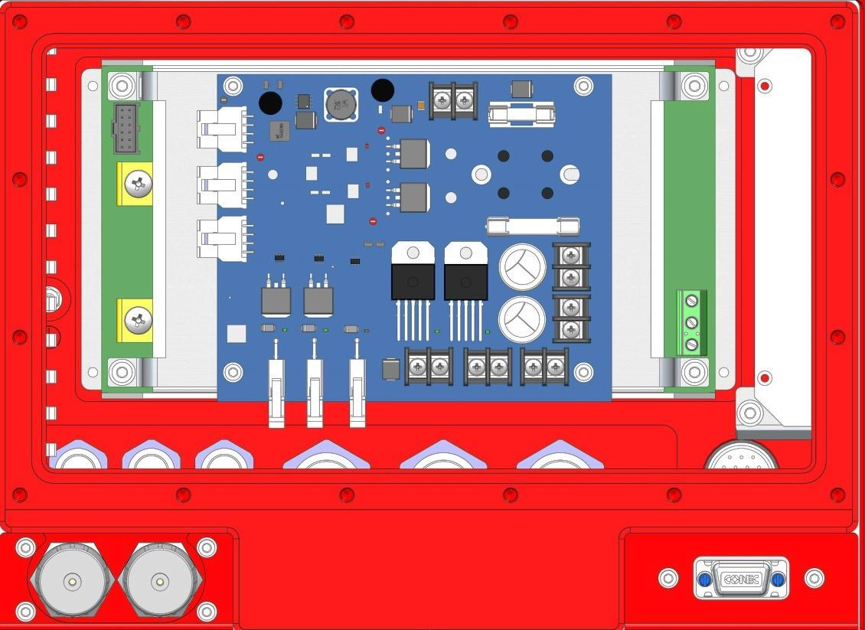

F1 (30А)

F2 (20А)

Figure 15 –Fuses F1 and F2 position

5.3.2. To replace FU1 fuse (Figure 16) carefully unscrew fuse holder counterclockwise on the power and control board. Replace a fuse with same value one from the spares and tools kit. Install holder back.

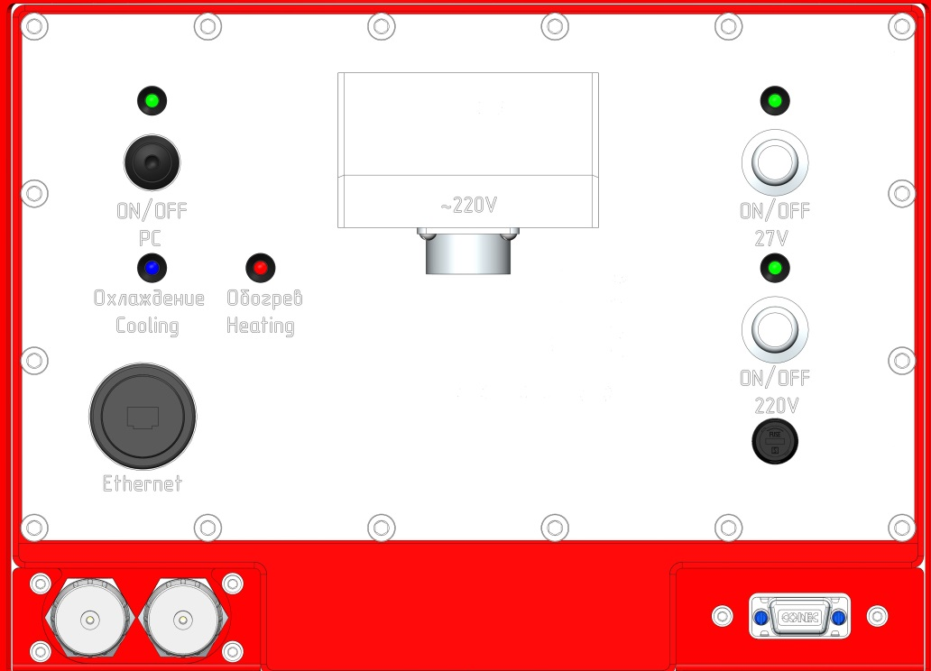

FU1, 10А

Figure 16 –FU1 fuse position

5.3.3. Functional diagram of power supply is presented in Figure 17.

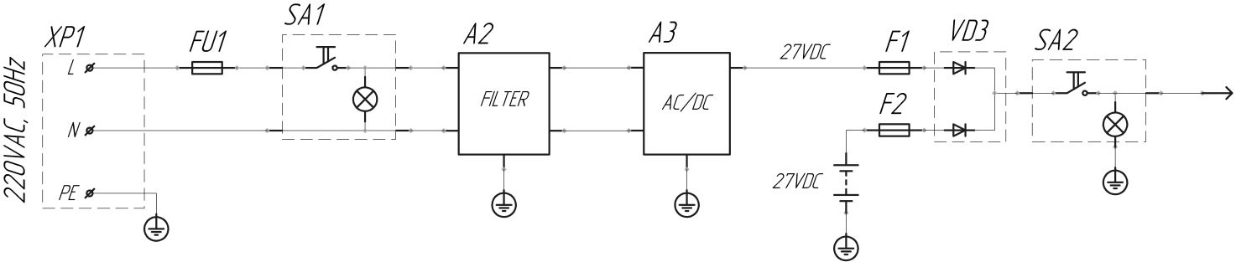

Figure 17 – Functional diagram of power supply

# Storage, preservation and UTILIZATION

6.1 For long-term storage (for a year and more) the product should be stored in a specially equipped heated room at a temperature from 5°C to 40 °C, with relative humidity up to 80% (for a temperature of 25°C), at absence of vapors of acids, alkalis and other corrosive substances in the air. Impact of corrosive environments on the product during storage is forbidden.

ATTENTION! BEFORE LONG-TERM STORAGE IT IS NECESSARY TO TAKE OFF THE CONNECTOR FROM ONE TERMINAL ON COMPLETELY CHARGED RECHARGEABLE BATTERIES (Figure 18).

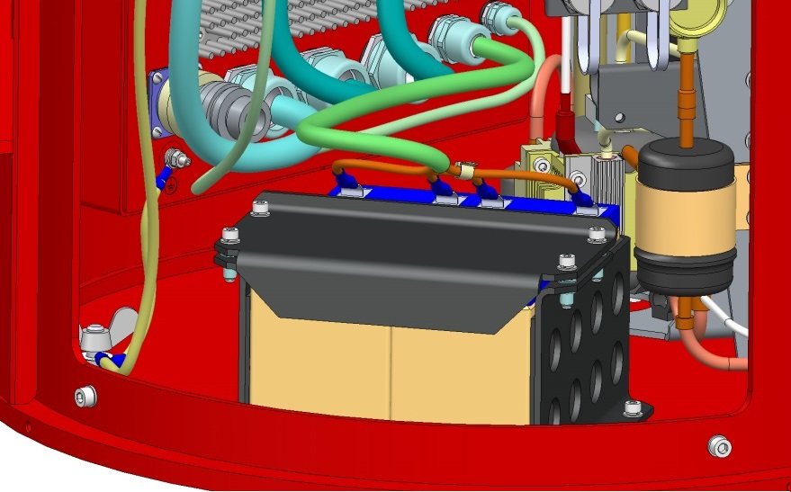

Terminals

Control and power board inner side

Figure 18 – Rechargeable batteries

For storage for less than a day at temperatures less than -40ºС the product should be covered with a heat-protective case.

Storage locations should be equipped with fire-extinguishing equipment and kept clean.

6.2 The product does not need preservation.

6.3 The product does not pose hazard to life, human health and environment and after the completion of operation is a subject to utilization.

Components of the product are subject to raw utilization with separation into ferrous and non-ferrous metals and plastic.

Separate components and elements of the product can be utilized according to operational documentation for them.

# packaging and Transportation

The product is packed in two special boxes providing protection from dust, moisture and vibration during long distance transportation.

Fastenings are provided to fix the cargo in appropriate for transportation position and to prevent it from free movement in the boxes.

During the loading and unloading operations impact of shock loads on the product’s packaging is forbidden.

Transportation of the product is performed in a specialized container providing reliable fixing and protection against external factors at storage and long distance transportation. During transportation available methods and schemes of fastening according to the selected type of transport excluding movements and collisions should be used.

Transportation of the product is performed in assembled form. The product should be transferred to the installation site by efforts of three persons at least, manually, using three special handles on the supports.

It is allowed to ship the product by any modes of transport:

– by motor transport on highways for a distance up to 3000 km with a speed up to 60 km/h;

– on unsurfaced roads for a distance up to 300 km with a speed up to 30 km/h;

– by rail, water and air transport without restriction of speed, distance and height.

During transportation the product can be both in horizontal, and in vertical position according to designations on boxes. It is recommended to pad shock-absorbing materials under boxes.

# StATEMENT OF WARRANTY

The manufacturer guarantees the product quality compliance with the requirements of the technical conditions as long as user of follows the rules of operation, storage, transportation and maintenance specified in the operating documentation.

Warranty period for WINDEX-2000 is 1 year from the date when Act of acceptance is signed.

In accordance with the terms of the contract, the manufacturer is obliged to repair or replace the Equipment or any of its parts, if it is found to be faulty or damaged due to the fault of manufacturer.

Warranty is not valid if user either reworks or repairs the device by himself or allows anybody to rework or repair the device without preliminary consent of a manufacturer in writing or damage is caused by negligent or incorrect operation by the user.

The warranty is not valid

– for damages caused by loading, transportation and unloading done by the company carrier

– for damages caused by independent installation and connection of the product by the customer;

– for damages caused by operation inconsistent with requirements specified in technical documentation;

- for consumable parts or materials and also for ordinary abrasions and scratches.

Warranty period for mounting works is set by the organization which performs mounting.

The warranty case is defined by manufacturer’s experts. For identification of a warranty case manufacturer’s experts in the presence of the customer or its representative make examination of the received damages and define the reason. Based on the expertize results a report signed by agents of the parties is drawn up.

# FACTORY ACCEPTANCE

Pulsed Doppler Wind Lidar WINDEX-2000 serial number _______________ is manufactured and accepted in accordance with mandatory requirements of the state standards, technical documentation and it is ready to use.

Head of Quality Control Department

.

________________________ ___________________________

sign Full Name

________________________

Date

Manufacturer name and adress:

Laser Systems Ltd.

34A, Svyazi Str, Strelna, St. Petersburg, 198515, Russia

phone (812) 612-02-88, fax (812) 777-78-30

E-mail: [office@lsystems.ru](mailto:office@lsystems.ru)

<http://www.lsystems.ru>

# THERMAL STABILIZATION SYSTEM INFORMATION

The refill is made: ____________________________

date

Refrigerant type:  ____________________________________

Refrigerant amount:  ______________________________

Oil type:  ______________________________________

Oil amount: ________________________________

Refrigerant refill information:

|  |  |  |  |  |
| --- | --- | --- | --- | --- |
| Refrigerant type | Amount | Refill date | Made by | |
| Full Name | Sign |
|  |  |  |  |  |
|  |  |  |  |  |
|  |  |  |  |  |
|  |  |  |  |  |
|  |  |  |  |  |
|  |  |  |  |  |
|  |  |  |  |  |
|  |  |  |  |  |
|  |  |  |  |  |
|  |  |  |  |  |